29.25: For the loop pulled through the region of magnetic field,
a)
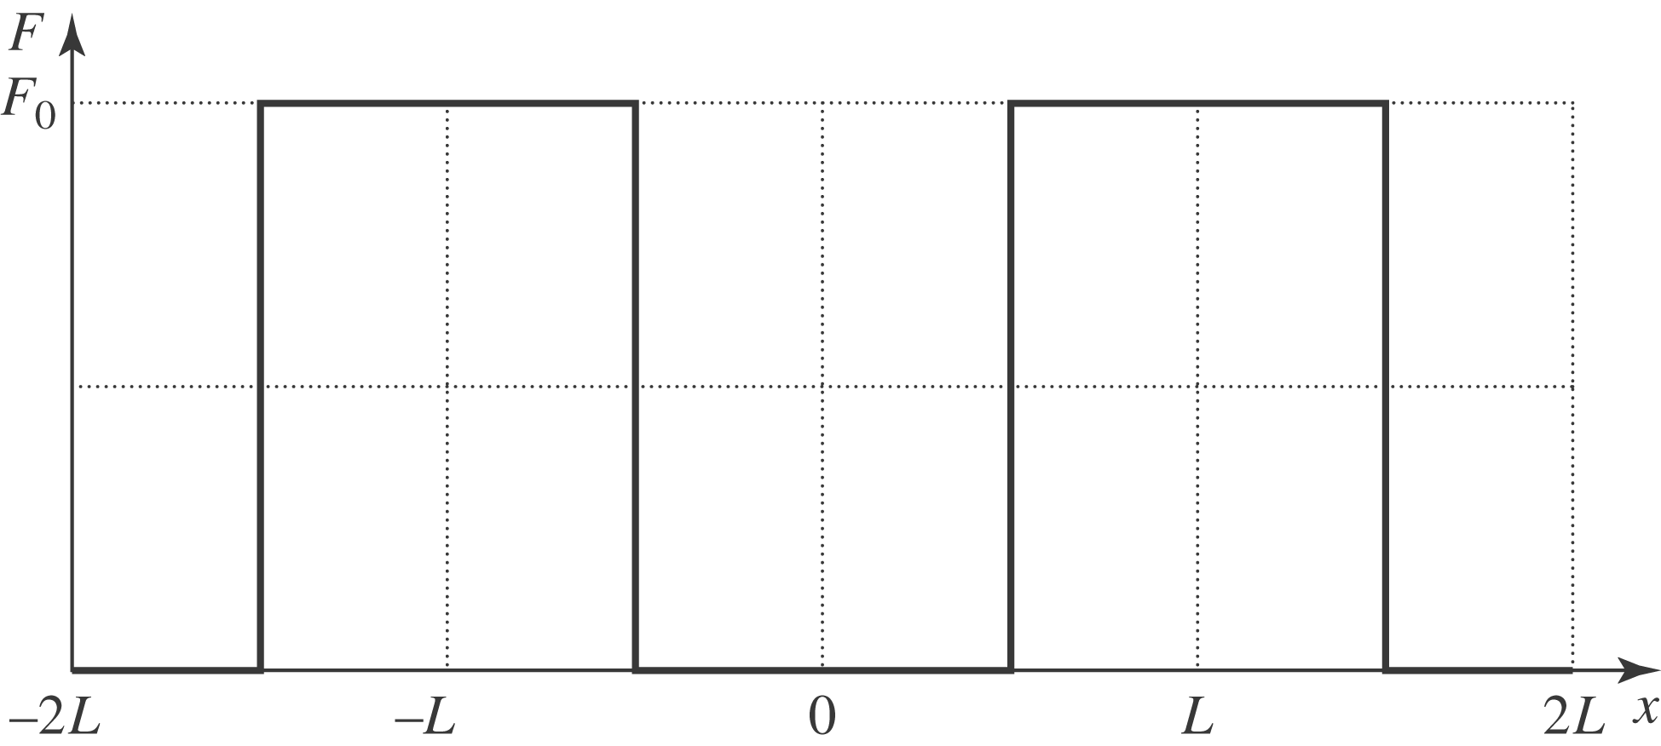
b)

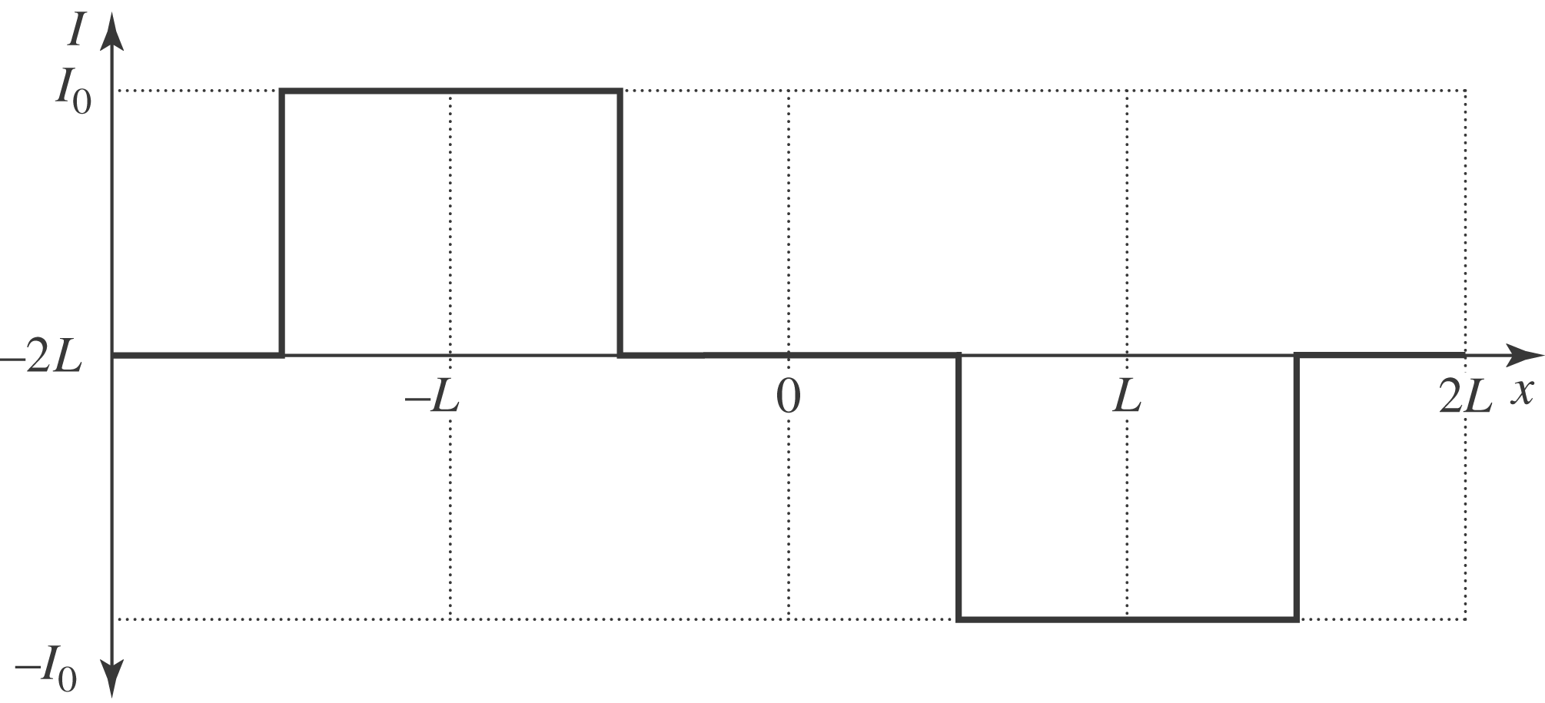

Where 